GLEN AUSTIN SPORTS CLUB WEBSITE

CHANGELOG
Project: Glen Austin Sports Club Website
Student: Sibusiso Myakayaka
Module: Web Development
Project: Part 1 – Building the Foundation / Part 2 – Designing the Visuals

Version 1.0 – Part 1: Building the Foundation

Initial Website Development
I started the Glen Austin Sports Club website by creating the basic structure using HTML. My main focus at this stage was to make sure that the website had the required pages, information and navigation before working on advanced visual styling.
The website was initially developed as a multi-page sports club website with pages such as:
- index.html
- about.html
- sports.html
- gallery.html
- join.html
- contact.html
I also created supporting folders and files for images, CSS, JavaScript and other project resources.

HTML Structure
I used HTML to create the main structure of the website. This included:
- Headings.
- Paragraphs.
- Images.
- Hyperlinks.
- Navigation.
- Lists.
- Tables.
- Forms.
- Labels.
- Sections.
- Header and footer elements.
- Alternative text for images.
- HTML comments.
At this stage, the website mainly depended on the browser’s default styling and basic HTML formatting.

Initial Appearance
The Part 1 website had a simple appearance. I used HTML attributes such as:
- bgcolor
- text
- align
- <font color="">
- Image width attributes.
- Table borders.
- <hr> elements.
The pages were mainly white with green text and orange headings.
Although the website contained the required information, the design was basic and did not have the same visual structure as the later CSS version.

Version 1.1 – Part 1 Navigation
I created navigation links so that users could move between the different pages of the website.
The navigation initially appeared as:
HOME | ABOUT US | FIXTURES | FACILITIES | MEMBERSHIP | CONTACT
I used links between the HTML pages so that visitors could access the different sections of the website.
The navigation worked for the basic desktop layout, but it was not designed specifically for smaller screens.

Version 1.2 – Part 1 Website Content
I added the main content required for the Glen Austin Sports Club website.
The website content included:
- Information about the club.
- The club’s history.
- Mission and vision.
- Sports and activities.
- Fixtures.
- Facilities.
- Membership options.
- Membership benefits.
- Contact information.
- Operating hours.
- Contact form.
The website content was organised into separate pages so that visitors could find information without having everything placed on one page.

Version 1.3 – Part 1 Images and Media
I added images to make the website more relevant to a sports club.
The project used images such as:
- hero.jpg
- team.jpg
- soccer.jpg
- cricket.jpg
- netball.jpg
- basketball.jpg
- athletics.jpg
I also used alternative text to describe the images.
The earlier version also included additional media content, including a video section on the homepage.

Version 1.4 – Part 1 Membership and Fixtures
I added tables to present information in a clearer format.

Membership
I created a membership table containing:
Membership Type | Annual Fee
Junior | R500
Adult | R800
Family | R1 500

Fixtures
I created a fixture schedule containing:
Date | Sport | Opponent | Venue | Time
15 August 2026 | Football | Midrand United | Glen Austin Sports Club | 15:00
22 August 2026 | Cricket | Midrand Cricket Club | Glen Austin Sports Club | 10:00
29 August 2026 | Football | Halfway House FC | Away | 14:00
5 September 2026 | Rugby | Midrand Rugby Club | Glen Austin Sports Club | 15:00
This helped me present information in a structured way instead of using large blocks of text.

Version 2.0 – Part 2: Applying CSS Styling
For Part 2, I introduced CSS to improve the overall appearance of the website.
The main change was moving from basic HTML formatting to a dedicated style.css file.
Instead of styling individual elements repeatedly inside the HTML, I used CSS to control the appearance of the website.

CSS Improvements
I used CSS to control:
- Colours.
- Fonts.
- Spacing.
- Navigation.
- Buttons.
- Images.
- Cards.
- Tables.
- Forms.
- Sections.
- Layout.
- Responsive behaviour.
- Hover effects.
- Overall page consistency.
This made the website easier to maintain because I could apply the same styles to multiple pages from one stylesheet.

Version 2.1 – New Colour Scheme and Branding
I created a consistent colour scheme for the website.
The main colours are:
- Green: #2E7D32
- Orange: #FF6F00
- White: #FFFFFF
Green represents the main club identity, while orange is used to highlight important headings, buttons and other elements.
I also introduced additional shades such as darker green and lighter background colours to create more separation between sections.
This was a major improvement from Part 1 because the website no longer depended mainly on plain white backgrounds, green text and horizontal lines.

Version 2.2 – Typography Improvements
I changed the typography to make the website easier to read and give it a more professional appearance.
I introduced:
- Montserrat for headings and stronger visual elements.
- Open Sans for normal body text.
In Part 1, the website mainly used the browser’s default font.
The new typography creates a clearer difference between headings and body text and makes the content easier to scan.
I also adjusted:
- Font sizes.
- Font weights.
- Line spacing.
- Heading sizes.
- Paragraph spacing.
This improved readability and gave the website a stronger visual identity.

Version 2.3 – Navigation Improvement
I redesigned the navigation from the basic HTML navigation used in Part 1.

Before
The old navigation consisted mainly of centred links separated by lines:
HOME | ABOUT US | FIXTURES | FACILITIES | MEMBERSHIP | CONTACT
It was functional, but it did not provide much visual hierarchy and was not designed for smaller screens.

After
I created a proper navigation bar using CSS.
The new navigation:
- Has a structured layout.
- Separates the club branding from the navigation links.
- Uses hover effects.
- Highlights important navigation elements.
- Remains visible while scrolling through the page.
- Changes into a mobile menu on smaller screens.
This made the website easier to navigate and gave the pages a more professional appearance.

Version 2.4 – Responsive Design
One of the biggest changes I made in Part 2 was making the website responsive.
Responsive design means that the website automatically adjusts its layout to fit different screen sizes, including:
- Desktop computers.
- Laptops.
- Tablets.
- Mobile phones.

Images
In Part 1, I used fixed image widths such as:
width="800"
and
width="400"
This meant that an image could be wider than a mobile phone screen.
In Part 2, I changed the image styling so that images can shrink when the screen becomes smaller.
The images can now use the available screen width without forcing the user to scroll sideways.
This improves the mobile experience.

Responsive Layout
The original website mainly stacked its content in one basic column.
In Part 2, I used CSS grids and flexible layouts.
For example, the sports section can display:
- Three cards across on a larger desktop.
- Two cards across on a smaller screen.
- One card per row on a mobile device.
This means the layout changes according to the available screen space instead of staying fixed.

Responsive Navigation
The original navigation was not designed specifically for mobile devices.
Six navigation links in one horizontal row can become difficult to use on a small screen.
In the new version, the navigation changes when the screen becomes smaller.
A mobile menu button is displayed and the navigation links can be shown vertically.
This makes the links easier to access and tap on a phone.

Version 2.5 – Media Queries and Breakpoints
I used CSS media queries to make the website respond to different screen sizes.
The CSS contains breakpoints that adjust the website when the screen becomes smaller.
For example, the website can change:
- Navigation layout.
- Number of grid columns.
- Heading sizes.
- Image sizes.
- Spacing.
- Form layouts.
- Card layouts.
The website therefore does not use one fixed design for every device.
Instead, the CSS responds to the available screen size.

Version 2.6 – Homepage Redesign
I redesigned the homepage to create a stronger first impression.
The new homepage includes a large hero section with:
- A background image.
- A dark overlay.
- Main heading.
- Supporting text.
- Call-to-action buttons.
The overlay helps make the text easier to read over the image.
I also added sections for:
- Welcome information.
- Club statistics.
- Sports.
- Fixtures.
- Calls to action.
- Video/media content.
The homepage therefore became more than just a list of information.
It now guides visitors towards important parts of the website.

Version 2.7 – Visual Layout Improvements
I changed the way information is visually presented.

Part 1
The information was mainly presented as:
- Headings.
- Paragraphs.
- Images.
- Horizontal lines.
This made the pages functional but visually repetitive.

Part 2
I introduced:
- Content cards.
- Grid layouts.
- Section backgrounds.
- Shadows.
- Borders.
- Buttons.
- Clear spacing.
- Visual hierarchy.
Sports information is now grouped into cards rather than appearing as plain text.
This makes related information easier to recognise.

Version 2.8 – Sports Cards and Services
I introduced cards for the sports and services sections.
The cards allow each sport or service to have its own visual area.
The card design includes elements such as:
- Image.
- Heading.
- Description.
- Spacing.
- Border styling.
- Shadow.
- Hover effects.
This gives the website a more organised appearance and makes the content easier to scan.

Version 2.9 – Image Improvements
I improved the way images are displayed using CSS.
Instead of relying only on fixed HTML widths, images can now respond to the size of the screen.
I also introduced more consistent image dimensions in areas such as the gallery.
Hover effects were added to some images to create a more interactive experience.
This makes the images feel like part of the website design rather than simply being placed between paragraphs.

Version 2.10 – Gallery Improvements
The gallery was improved from the simpler image presentation used previously.
The new gallery uses a CSS grid so that images can be displayed in organised rows and columns.
The gallery can change its number of columns depending on the screen size.
This means the gallery can adapt from a larger desktop display to a smaller tablet or mobile layout.

Version 2.11 – Forms and Contact Improvements
I improved the forms to make them easier to understand and use.
The forms now use:
- Clear labels.
- Appropriate input types.
- Required fields.
- Better spacing.
- Consistent styling.
- Focus states.
When a user selects an input field, the focus styling makes it clearer which field they are currently using.
This improves usability and makes the form easier to complete.

Version 2.12 – Accessibility Improvements

Figure 1:Website Layout on a foldable mobile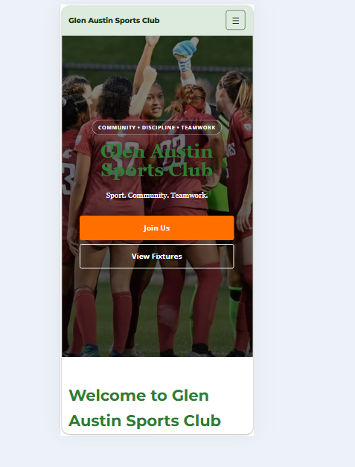
I made several changes to improve accessibility.
Images were given descriptive alternative text so that their content can still be understood by users who may not be able to see the image.
I also improved:
- Form labels.
- Navigation.
- Text readability.
- Colour contrast.
- Focus states.
- Mobile usability.
These changes make the website easier to use for different types of users.

Version 2.13 – User Experience Improvements

Figure 1: Website layout on a tablet

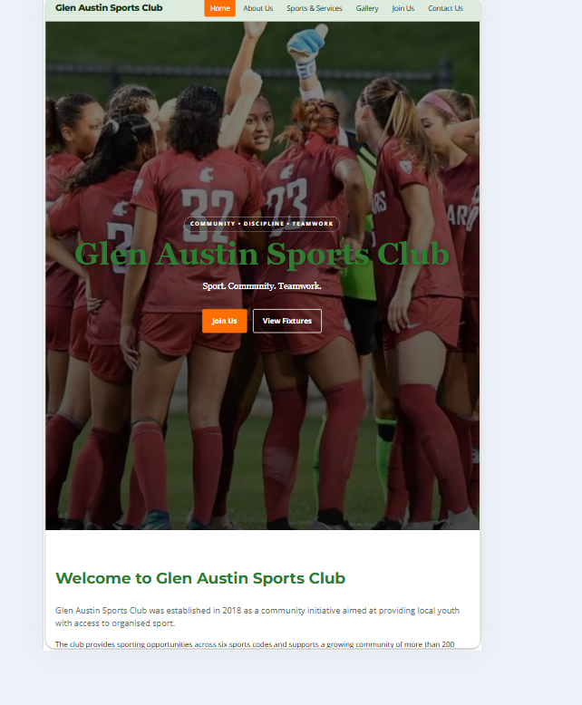

Figure 1: Website layout on a tablet
I redesigned the website with the user experience in mind.
In Part 1, the website mainly provided information.
In Part 2, I added visual elements that help guide the user through the website.
These include:
- Hero sections.
- Call-to-action buttons.
- Sports cards.
- Statistics.
- Clear section headings.
- Improved navigation.
- Consistent page layouts.
- Improved forms.
- Gallery presentation.
- Multimedia content.
For example, buttons such as Join Us and View Fixtures give visitors a clear next step instead of making them search through the page for what to do.

Version 2.14 – Mobile User Experience

Figure 2: Website Layout on a mobile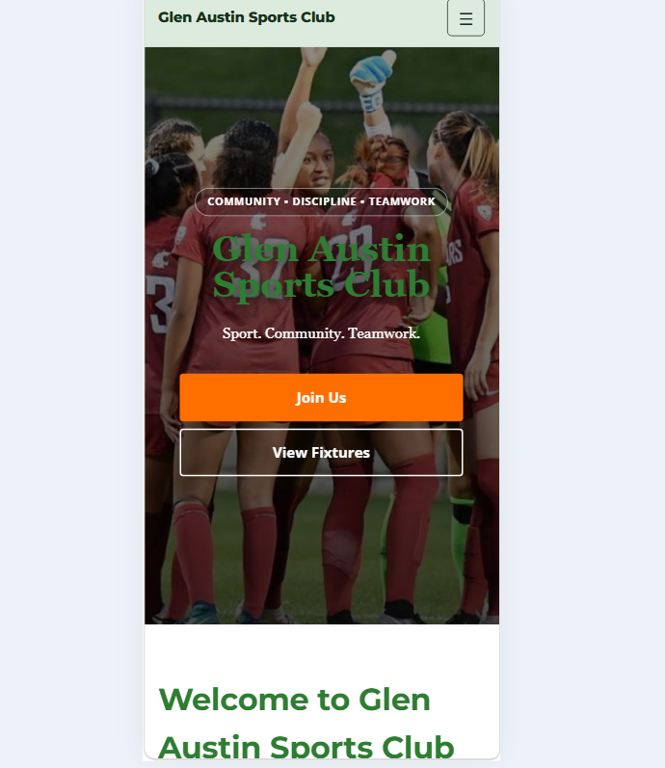
I specifically improved the website for mobile users.
The new design reduces the problems that existed with the old fixed-width layout.
The website now allows:
- Images to shrink.
- Content grids to change columns.
- Navigation to change into a mobile menu.
- Headings to become smaller.
- Text to fit smaller screens.
- Forms to adjust to available space.
This reduces the need for sideways scrolling and makes the website easier to use on a phone.

Version 2.15 – Consistency Across Pages
I applied the same visual design across the different pages.
The pages now share:
- The same colour scheme.
- The same typography.
- The same navigation.
- Similar headings.
- Similar buttons.
- Consistent spacing.
- Similar cards.
- Consistent footer design.
This makes the pages feel like parts of one website instead of separate HTML documents.

Version 2.16 – Overall Part 1 to Part 2 Improvement
The change from Part 1 to Part 2 was a major improvement.

Part 1
The original website focused mainly on:
- HTML structure.
- Basic formatting.
- Information.
- Navigation.
- Images.
- Tables.
- Forms.
The website worked, but the design was basic and rigid.

Part 2
I added:
- CSS.
- Custom fonts.
- A consistent colour scheme.
- Responsive layouts.
- Media queries.
- Flexible images.
- Navigation improvements.
- Mobile navigation.
- Cards.
- Buttons.
- Hero sections.
- Improved forms.
- Hover effects.
- Accessibility improvements.
- Better spacing.
- Better visual hierarchy.
- Improved user experience.

Version 3.0 – Current Website
The current version combines the information and structure developed in Part 1 with the visual and responsive improvements introduced in Part 2.
The current website is organised around the following main pages:
- Index.html
- About.html
- Fixtures.html
- Facilities.html
- Membership.html
- Contact.html
The website now provides a more structured experience across desktop, tablet and mobile devices.

Current Website Content
The current website provides information about:

About the Club
I included information stating that Glen Austin Sports Club was established in 2018 in Glen Austin, Gauteng, as a community initiative to provide local youth with access to organised sport.

Mission
The mission focuses on:
- Community wellness.
- Discipline.
- Teamwork.
- Affordable sporting opportunities.
- Accessibility.

Vision
The vision focuses on creating an inclusive and competitive community sports club in Midrand while developing talent and future leaders.

Values
The current values include:
- Teamwork.
- Respect.
- Discipline.
- Fair Play.
- Community.
- Excellence.

Current Membership Information
I included three membership options:
Membership Type | Annual Fee
Junior | R500
Adult | R800
Family | R1 500
The Membership page also explains the benefits of joining and provides a way for visitors to contact the club.

Current Contact Information
The website currently displays:
Email:
info@glenaustinsportsclub.co.za
Telephone:
011 555 0123
Location:
Glen Austin, Midrand, Gauteng, South Africa
The Contact page also includes operating hours and a contact form.

Current Project Notes
While reviewing the current version, I identified a couple of content differences that I need to keep in mind for future updates.
The About page states that the club has six sports codes, while the Home and Facilities pages currently display five:
- Soccer
- Cricket
- Netball
- Basketball
- Athletics
Rugby also appears in the Fixtures page through the fixture against Midrand Rugby Club, but Rugby is not currently included in the Home or Facilities sports lists.
I have recorded these differences rather than changing the project information without deciding which version should be used.

Final Part 2 Summary
Overall, I changed the Glen Austin Sports Club website from a basic HTML website into a more visually structured, responsive and user-friendly website.
In Part 1, I concentrated on building the foundation of the website by creating the HTML pages, navigation, content, images, tables and forms.
In Part 2, I used CSS to improve that foundation. I introduced a consistent green, orange and white colour scheme, new fonts, better spacing, cards, buttons, responsive grids, flexible images, a redesigned navigation bar and improved forms.
I also made the website responsive. The old website used fixed widths and did not properly adapt to smaller screens. The new version uses flexible layouts, responsive images and media queries so that the website can adjust to desktop, tablet and mobile screens.
The navigation also changed from a basic row of links into a responsive navigation system that can become a mobile menu. The typography, images, forms and page layouts were also improved to make the website easier to read and use.
The biggest improvement is that the website is no longer only focused on providing information. I designed it to guide the user through the content using clear sections, visual hierarchy, buttons, cards, images and calls to action.
Part 1 gave me the foundation of the website, while Part 2 allowed me to turn that foundation into a more organised, responsive and visually appealing website.

Version 4.0 – Part 3: Website Functionality and Development
For Part 3, I focused on improving the functionality of the Glen Austin Sports Club website. In the previous parts, I created the website structure and improved its appearance using CSS. In this part, I worked on JavaScript, form validation, email submission, user feedback, GitHub and website deployment.
The main goal was to make the website more interactive and allow visitors to communicate with the club through working forms.

Version 4.1 – JavaScript Functionality
I used JavaScript to add interactive features to the website.
The JavaScript file is stored in the js folder as script.js.
I added functionality such as:
- Mobile navigation menu.
- Automatic copyright year in the footer.
- Gallery image lightbox.
- Sports search and filtering.
- Smooth scrolling.
- Reveal animations.
- Accordion functionality.
- Interactive map on the Contact page.
These features allow visitors to interact with different parts of the website instead of only viewing static information.

Version 4.2 – Contact Form Validation
I improved the Contact Us form to make sure visitors provide the required information before submitting it.
The form includes fields for:
- Name.
- Email address.
- Message type.
- Message.
I used HTML form validation and JavaScript to check the submitted information.
If required information is missing or invalid, the browser displays a validation message. This helps visitors correct their information before submitting the form.

Version 4.3 – Contact Form Email Integration
I connected the Contact Us form to Formspree so that submitted messages could be delivered to the club’s email address.
I used the Formspree endpoint to process the form submissions.
I also added JavaScript to handle the submission without requiring the visitor to reload the page.
The form now provides feedback when:
- The message is being sent.
- The message has been sent successfully.
- An error occurs during submission.
After a successful submission, the form fields are cleared while the success message remains visible.

Version 4.4 – Enquiry Form Improvements
I improved the Enquiries page to make it easier for visitors to send questions and requests to the club.
The form includes:
- Name.
- Email address.
- Phone number.
- Enquiry type.
- Enquiry details.
I added validation to make sure the required information is entered correctly. I also added a minimum length check to the enquiry details field so that visitors provide enough information about their enquiry.
I adjusted the submit button to make it more compact and consistent with the website design.

Version 4.5 – Enquiry Form Email Integration
I connected the Enquiries form to Formspree using the same email submission service as the Contact Us form.
I added JavaScript to process the information and display feedback to the visitor.
The form displays a sending message while the enquiry is being processed. It then displays a success message if the submission is accepted or an error message if something goes wrong.
After a successful submission, the form is reset so that the visitor can see that the information has been cleared. The success message remains visible.

Version 4.6 – Form Styling and User Feedback
I improved the appearance of the form feedback messages using CSS.
I created different styles for:
- Loading messages.
- Successful submissions.
- Error messages.
I also used accessible status messages so that visitors can receive feedback when a form is submitted.
These improvements make it easier for visitors to understand what is happening after they submit their information.

Version 4.7 – GitHub Repository and Version Control
I created a GitHub repository for the Glen Austin Sports Club website.
Repository: WEDE502---Part-3
I uploaded the website files and supporting resources to GitHub.
I organised the project files into folders, including:
- css – contains the website stylesheet.
- js – contains the JavaScript file.
- images – contains the website images.
I also used descriptive commit messages to record changes made to the project.
GitHub allows me to keep a record of the website development and store the project online.

Version 4.8 – README Documentation
I created and updated the README file to provide information about the website project.
The README includes:
- Project description.
- Project purpose.
- Website features.
- Technologies used.
- Project folder structure.
- Instructions for accessing the website.
- Relevant project information.
This documentation helps explain how the website is organised and what it is designed to do.

Version 4.9 – Website Deployment
I deployed the Glen Austin Sports Club website using GitHub Pages.
I configured GitHub Pages to publish the website from the main branch and the root folder of the repository.
I also checked the website after deployment and corrected the file and folder structure so that the browser could locate the CSS, JavaScript and image files.
The website is now accessible online and can be opened using a web browser on a computer or mobile phone.

Version 4.10 – Sitemap and Robots File
I added a sitemap.xml file to provide a list of the website pages for search engine discovery.
I also added a robots.txt file to provide instructions to search engine crawlers.
These files form part of the website’s technical setup and help search engines understand the website structure.

Version 4.11 – Website Testing and Final Improvements
After completing the development work, I tested the website to check that its main features were working correctly.
I checked:
- Navigation links between pages.
- Mobile navigation.
- Images and CSS styling.
- JavaScript functionality.
- Contact form submissions.
- Enquiry form submissions.
- Form validation and feedback messages.
- Website loading on a laptop and mobile phone.
- GitHub Pages deployment.
I also checked that the website files were organised correctly so that the deployed version could load the required resources.

Final Part 3 Summary
In Part 3, I focused on making the Glen Austin Sports Club website functional and accessible online.
I used JavaScript to add interactive features, including mobile navigation, gallery functionality, sports filtering and form processing.
I improved the Contact Us and Enquiries forms by adding validation, email integration and feedback messages. This allows visitors to submit their information and receive a response indicating whether their submission was successful.
I also created a GitHub repository, organised the project files, updated the README and changelog, and deployed the website using GitHub Pages.
Part 1 gave me the HTML foundation of the website. Part 2 improved its appearance and responsiveness through CSS. Part 3 added functionality, form processing, version control and online deployment.
The Glen Austin Sports Club website is now a multi-page website that visitors can access online and use to find club information, explore sports, view the gallery and contact the club.

